**Introduction:**

Organizational [performance](https://www.marketing91.com/performance-based-marketing/) is one of the most vital aspects of an organization, no matter what the type. It is a way that is used to measure the value of a company “by comparing their actual output with the output that had been initially intended [goal and vision]” (Bhasin, 2020). This is done by checking 3 areas: [Product](https://www.marketing91.com/what-is-a-product/) [market](https://www.marketing91.com/market/) performance, (market shares, sales, etc.) Financial performance (assets, profit, etc.) and Shareholder’s return(money received by shareholders). But no matter which area is considered, certain concepts can be said to directly impact them and thus impact the organizational performance. These are: Nominal and Delphi technique, piecework and stock option, feedback and feed-forward control, product and matrix departmentalization, and initiating structure and consideration leadership styles.

So, in this essay, I will go over these concepts and link their use to famous companies worldwide (Amazon, Bell Canada, Genetech Inc, LAGear, Starbucks, Facebook and Apple Inc) to show their impacts on the performance of an organization.

**Discussion:**

1. **Nominal Technique and Delphi Technique:**

Nominal Technique and Delphi Technique are parts of the group decision making technique. According to Tang et all (2021), they are used when decision makers need to find the best solution from its alternatives, comparing their preferences and opinions, with the final solution being a responsibility of the whole group instead of any single individual. Although they are both used to make decisions, their processes are quite different, leading them to be suitable for different situations. For instance, in Amazon, nominal technique is performed by senior executives where they start their group meetings with “everyone reading six-page narrative memos about the topic they are gathered to discuss, for up to 30 minutes” (Larson, 2018). But in “Bell Canada”, as seen by Arthur (2021) and Lawrence (2003), the employees instead follow the Delphi technique where they discuss important topics, like determining the future course of technology with panel of experts. Then again, in this fast paced world, there are cases when neither is right, as the decisions need to be made instantly. This can be solved by using the High-velocity decision-making technique to make quick, calculated, risk-taking decisions for products or resources, as done by Jeff Bezos from Amazon following the thoughts “move fast and break things” “it is always Day 1 [at Amazon]” (Benson, 2019). Even so, it’s hard to deny the positive impacts Nominal and Delphi techniques have on proper decision making and thus also on the organizational performance.

1. **Piecework and Stock option:**

When considering organizational performance, one must not only consider how the decisions are being made, but also on the motivations of the people making them. After all, as stated by Dutta **(**2021), without adequate motivation, an employee won't give his or her best and work hard, leading to lower productivity of employee and lower performance of the company. Thus, it is quite easy to understand how compensation decisions like piecework and stock option, which increases employee motivation, can improve organizational performance. But the level of increase actually depends on the company, type of compensation taken and the situation or environment the employees are in. For instance, as observed by Hart (2016), during the first parts of the 20th century, British manufacturing industries (like Engineering and Metalworking industries) were continuously using piecework to not only pay extra compensations to their employees and increase their productivity, but also to decrease monitoring expenses (as number of product produced by employees determined their fee and thus no need for extra monitoring). But unfortunately, in modern times, most companies have shifted from low-technology manufactured goods to high-end products. This change has led to big companies like Genetech Inc to give Stock options (the ability to purchase company stocks at a set, lower price) to employees instead, as a form of extra compensation [ as seen in Genetech Inc. -Exhibit-10.18(2004) ], rather than using piecework. Even so, the fact that these techniques increase employee’ performance [ as noticed by Sudiardhita et al (2018) ], via extrinsic motivation, and hence leads to increase in organizational performance [ as found by (Rana et al, 2017) ], is undeniable.

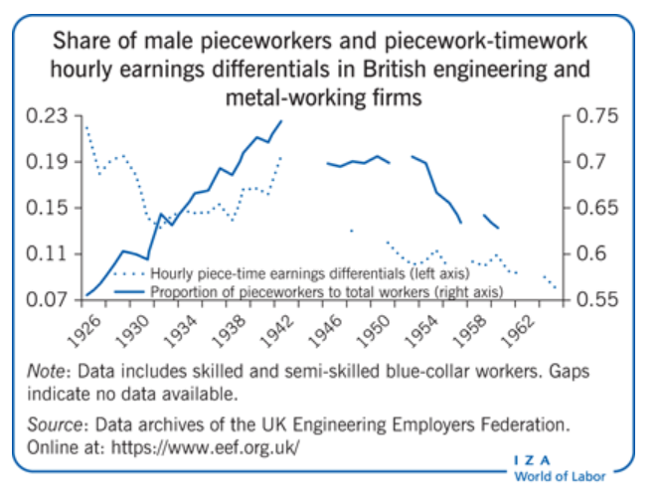

1. **Feedback vs. Feed-forward:**

But even though employees are working with full motivation and productivity, unforeseen disruptions may occur in the company, like an Amazon return warehouse in Kentucky closing due to Covid-19 crisis, causing storage and supply issues [ as noted by Montgomery (2020) ]. This leads to a decrease in organizational production levels which in turn decreases their performance. In such situations, the feedback control systems are usually used by the companies in order to gather information about the performance deficiency (and their causes), after they occur. Then these information are used to make certain corrections, like optimizing production scheduling [ as done by Ikome et all (2018) ], encouraging employees to make independent decision to solve problems [ as written in Culture Partners (2020) ], etc. But in this type of control system, there are delays between performance deficiency and the feedback. Thus, in this current, fast-paced, technological environment, the feedback system is too slow. So, most smart companies have switched to feed-forward control system instead [ as noted by **John(2015**) ] where they focus on controlling inputs, to prevent the deficiencies from occurring from the very start. This has also shown “to increase both the creativity of the employees and also the cost-cutting [in organizations]’ (Simanjuntak, 2018), both of which lead to increase in organizational performance.

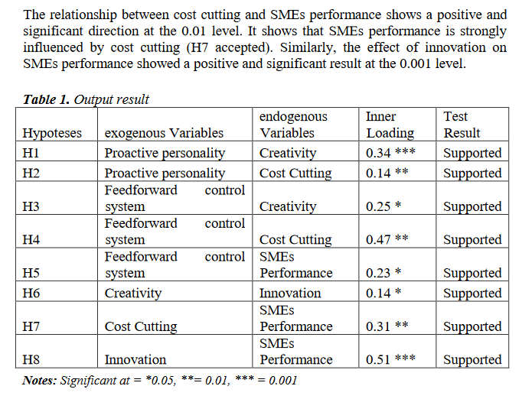

1. **Product Departmentalization vs. Matrix Departmentalization:**

Some companies, like LAGear [ as stated in Wikipedia (2021) ] have discovered that productivity and performance can be further increased by using product departmentalization structure. There they divide their workforce into certain groups and give each group the responsibility of a certain product. This structure is quite beneficial as it is highly flexible (companies can easily add new product line if needed) and produces better quality goods (as is follows principle of specialization and fully utilizes human and nonhuman resource) [ as stated in Business Marketing (2017) ]. But unfortunately, since department managers focus on their own products, they end up having a limited view of (or even ignoring) the organizational goals. Thus companies like Starbucks decided to use a matrix departmentalization instead [ as noticed by Sobiya (2018) ]. There they integrated geographic, functional, team and product departmentalization, combining the advantages from each. Although, the matrix structure enabled them to increase their organizational production levels, performance and overall growth [ as found by the Trefis Team (2016) ], it has also developed a deadly flaw. This is because now the employees had to answer to both functional and geographic bosses at the same time, leading to a duplication of authority. Thus, the organization must spend extra time and resources in training now to ensure the employees know which orders to follow and prioritize, in order to avoid losing this increase in organizational performance.

1. **Initiating Structure and Consideration leadership:**

But changing the entire organizational structure is generally viewed as a costly step with the increase in performance not being on par with the expense. Thus companies instead prefer utilizing leaders to guide and motivate the employees instead. For instance, Steve jobs from Apple Inc. used to use initiating structure (task-oriented leadership) style [ as stated by Ansary (2020) ] where he set roles, tasks and deadlines for his employees, enabling them to increase their productivity and thus the organization’s performance. But, as seen in his case, if leaders are too focused on tasks, they will end up creating a distance between them their subordinates, leading to a cold, demotivating working environment. Thus organization, like the police [ as noted by Donald (2003) ], nowadays prefers their leaders follow consideration style instead and help encourage, support and increase the morale of their employees. But being overly considerate may lead to employees being lazy or slacking off. So, it’s better to have a transformational leader like Mark Zuckerberg of Facebook [as observed by Financhill (2020) and (Dr. Clark (2021) ] instead, who can focus on both the task and the people doing the task, creating a positive organizational culture and ensuring high level of productivity and performance of the organization

**Conclusion:**

So, overall, Organizational performance, the heart of the organization, can be improved by utilizing these concepts (Nominal and Delphi technique, piecework and stock option, feedback and feed-forward control, product and matrix departmentalization, and initiating structure and consideration leadership styles) individually, at their proper places, as seen in companies like Amazon, Bell Canada, Genetech Inc, LAGear, Starbucks, Facebook and Apple Inc, etc. Thus, if a single company utilized all of these techniques, it would not only get a huge boost in its performance, but would also be able to reach unimaginable heights.

**References:**

# [Bhasin](https://www.marketing91.com/author/admin/),H 2020, *Organisational Performance Definition and Factors,*Marketing91, viewed 10th Oct 2021,<<https://www.marketing91.com/organisational-performance/>>

# Tang M., Liao H. 2021, ‘From conventional group decision making to large-scale group decision making: What are the challenges and how to meet them in big data era? A state-of-the-art survey’, *Omega*, , April, Volume 100, viewed 10th Oct 2021<<https://doi.org/10.1016/j.omega.2019.102141>>

# Larson, E 2018, ‘How Jeff Bezos Uses Faster, Better Decisions To Keep Amazon Innovating’, *Forbes*, 24th September, viewed 10th Oct 2021, <[https://www.forbes.com/sites/eriklarson/2018/09/24/how-jeff-bezos-uses-faster-better-decisions-to-keep-amazon-innovating/?sh=2f0f3c667a65](https://www.forbes.com/sites/eriklarson/2018/09/24/how-jeff-bezos-uses-faster-better-decisions-to-keep-amazon-innovating/?sh=2f0f3c667a65%20)>

# Arthur, G. S. 2021, ‘DELPHI TECHNIQUE’*, Reference for Business*, viewed 10th Oct 2021,<[https://www.referenceforbusiness.com/encyclopedia/Cos-Des/Delphi-Technique.html#ixzz77quEstSF](https://www.referenceforbusiness.com/encyclopedia/Cos-Des/Delphi-Technique.html#ixzz77quEstSF )>

# Lawrence, H. S. 2002, ‘III.C.1. Delphi Research in the Corporate Environment’, *The Delphi Method: Techniques and Applications*, viewed 10th Oct 2021, <<https://web.njit.edu/~turoff/pubs/delphibook/ch3c1.html>>

# Bemson,B. 2019, ‘Ex-Amazon manager: Jeff Bezos is ‘obsessed’ with this decision-making style—‘it’s his key to success’ ’ *, CNBC LLC*, viewed 10th Oct 2021, <<https://www.cnbc.com/2019/11/14/how-billionaire-jeff-bezos-makes-fast-smart-decisions-under-pressure-says-ex-amazon-manager.html>>

# Dutta S. 2021, ‘Employee Motivation- A Comprehensive Guide’, *Employee Engagement*, 28th July, viewed 10th Oct 2021, <<https://blog.vantagecircle.com/employee-motivation/>>

# Hart A.R. 2016, ‘The rise and fall of piecework Incidence of piecework has significantly reduced in advanced industrialized economies—has its decline gone too far?’, *IZA World of Labor*, April, viewed 10th Oct 2021, <<https://wol.iza.org/articles/rise-and-fall-of-piecework/long>>

# GENENTECH, INC. 2004, *GENENTECH, INC. EQUITY INCENTIVE PLAN*, GENENTECH, INC., viewed 10th Oct 2021, <<https://www.sec.gov/Archives/edgar/data/318771/000031877104000005/dna-ex10_18.htm>>

# Sudiardhita, K. I. R., Mukhtar, S., Hartono, B., Herlitah, Sariwulan, T., & Nikensari, S. I. 2018, ‘THE EFFECT OF COMPENSATION, MOTIVATION OF EMPLOYEE AND WORK SATISFACTION TO EMPLOYEE PERFORMANCE PT. BANK XYZ (PERSERO) TBK’, *Academy of Strategic Management Journal, 17*(4), 1-14, viewed 10th Oct 2021, < <https://www-proquest-com.ezproxy.lib.swin.edu.au/docview/2124080491?pq-origsite=primo>>

[Rana, M.H.](https://www-emerald-com.ezproxy.lib.swin.edu.au/insight/search?q=Muhammad%20Habib%20Rana" \o "Muhammad Habib Rana)& [Malik, M.S.](https://www-emerald-com.ezproxy.lib.swin.edu.au/insight/search?q=Muhammad%20Shaukat%20Malik) 2017, ‘Impact of human resource (HR) practices on organizational performance: Moderating role of Islamic principles’, [*International Journal of Islamic and Middle Eastern Finance and Management*](https://www-emerald-com.ezproxy.lib.swin.edu.au/insight/publication/issn/1753-8394), Vol. 10 No. 2, pp. 186-20, viewed 10th Oct 2021, <<https://doi-org.ezproxy.lib.swin.edu.au/10.1108/IMEFM-04-2016-0060>>

# Montgomery O. 2020 ‘5 Types of Supply Chain Disruption with COVID-19 Examples’, *Software Advice*, viewed 10th Oct 2021, <<https://www.softwareadvice.com/resources/supply-chain-disruption-types/>>

Ikome, J. M. & Kanakana G. M. 2018, ‘An Optimization of Manufacturing Systems using a Feedback Control Scheduling Model’, [*IOP Conference Series: Materials Science and Engineering*](https://iopscience.iop.org/journal/1757-899X)*,* viewed 10th Oct 2021, <<https://iopscience.iop.org/article/10.1088/1757-899X/320/1/012013>>

# Culcture partners 2020, ‘4 Companies Winning with Feedback in the Workplace’, *Culture Partners,* viewed 10th Oct 2021, <<https://culture.io/companies-that-understand-importance-of-feedback-in-the-workplace/?pil=landed>>

# John D. A. 2015, ‘From feedback to feedforward’, *Business Standard,* 9th March, viewed 10th Oct 2021, <<https://www.business-standard.com/article/management/from-feedback-to-feedforward-115030800596_1.html>>

# Simanjuntak D. A. 2018, ‘The Role of Feedforward Control System in Improving SMEs’ Performance’*, European Research Studies Journal Volume XXI* , Issue 3, pp. 378-390, viewed 10th Oct 2021, <<https://www.ersj.eu/dmdocuments/2018_XXI_3_30.pdf> >

# Wikipedia 2021, ‘Departmentalization’, *Wikipedia,* viewed 10th Oct 2021, <<https://en.wikipedia.org/wiki/Departmentalization> >

# Business Marketing 2017, ‘Advantages and Disadvantages of Departmentation by Product and Services’, *Business-Marketing,* August, viewed 10th Oct 2021, <<https://marketinglord.blogspot.com/2017/08/advantages-and-disadvantages-of_17.html>>

# Sobiya 2018, ‘Understanding Starbucks Organizational Structure’, *Advergize,* 28th July, viewed 10th Oct 2021, < <https://www.advergize.com/business/starbucks-organizational-structure/>>

# Trefis Team, 2016, ‘Let's Look At Starbucks' Growth Strategy’, *Forbes*, 19th September, viewed 10th Oct 2021, <<https://www.forbes.com/sites/greatspeculations/2016/09/19/lets-look-at-starbucks-growth-strategy/?sh=68f1c2cb3d71>>

# Ansary A. S. 2020, ‘Steve Jobs Leadership Style that Made Him Great’, *Career Cliff Career Blog,* 1stMarch, viewed 10th September, 2021, <<https://www.careercliff.com/steve-jobs-leadership-style/>>

# Grinder D. 2003, ‘People-Oriented Leadership’, Police Chief, Volume: 70, Issue: 10, Pages: 30, 33 & 34, October, viewed 10th Oct 2021, <<https://www.ojp.gov/ncjrs/virtual-library/abstracts/people-oriented-leadership>>

# Financhill, 2020, ‘Mark Zuckerberg Leadership Style’ *Financhill,* viewed 10th Oct 2021, <<https://financhill.com/blog/investing/mark-zuckerberg-leadership-style>>

# Dr. Clark E. 2021, ‘Mark Zuckerberg and Facebook Leadership’, *Elijah Clark Neuromarketing Consultant*, 24th April, viewed 10th September 2021, <<https://elijahclark.com/mark-zuckerberg-facebook-leadership/>>